Project Report on
USER MANAGEMENT APP
BACKEND PROJECT

- Submitted To –
Department of Computer Application
Gopikabai Sitaram Gawande College Umarkhed

- Guided By -
Prof. Pravin Nakhate

- Submitted By -
Pankaj Digambar Narwade
Bachelors of Computer Application Final Year

In Partial Fulfilment of the requirements of Degree Bachelors of Computer Application Sant Gadge Baba , Amaravati University , Amaravati Year (2023-2024)
CERTIFICATE

This is to certify that Mr Pankaj Digambar Narwade Student of Bachelors of Computer Application (Final Year) has successfully completed the Project work of User Management App using backend Technologies, and has submitted about it in the partial fulfilments of the requirements of the degree of Bachelors of Computer Application .

Date : /04/2024

Examiner Guide

Head of the Department
Department of Computer Application
Gopikabai Sitaram Gawande College Umarkhed
Sant Gadge Baba , Amaravati University,
(2023-2024)
ACKNOWLEDGEMENT

I would like to express my profound gratitude to Mr.P.K. Nakhate sir HOD of Bachelor of Computer Application department, and all Teacher staff of this Department for their contributions to the completion of my project titled User Management App.
While submitting the project , I take an opportunity to thank all the management staff of the computer department for timely guiding and helping us to complete this job without their valuable support this project could not be successful.
I would like to express my special thanks to our mentor Mr.S.S.Tawde sir for his time and efforts he provided throughout the year. Your useful advice and suggestions were really helpful to me during the project’s completion. In this aspect, I am eternally grateful to you.
I would like to acknowledge that this project was completed entirely by me and not by someone else.

Signature
Pankaj Digambar Narwade
BCA III Year
(2023 – 2024)

TABLE OF CONTENTS

Sr.no. |  | Particulars | Page no.
1 |  | Abstract
2 |  | Introduction
3 |  | Objective
 |  | Scope of Proposed System
4 |  | Technology used
 | 4.1 | Frontend
 | 4.2 | Backend
5 |  | Features
 | 5.1 | Home Page
 | 5.2 | User Page
 | 5.3 | Add New User
 | 5.4 | Delete User
6 |  | ER-Diagram and Graph
7 |  | Implementation
 | 7.1 | Frontend
 | 7.2 | Backend
8 |  | Conclusion
9 |  | H/W & S/W Requirements
10 |  | Website View

ABSTRACT
The "User Management App" is a comprehensive web application designed to efficiently manage user data. Leveraging HTML, CSS, JavaScript, Node.js, Express.js, MySQL, and EJS template engine, the project offers a robust platform for user interaction and data handling.

The app features a user-friendly interface with distinct functionalities spread across multiple pages. The Home Page serves as a dashboard, displaying the total user count and providing navigation to the Users Page.

On the Users Page, users can view all registered users in a tabular format, with options to edit and delete user details. Authentication mechanisms ensure secure access, requiring users to provide correct credentials for any modifications.

Adding a new user is simplified through the Add New User Page, featuring input fields for name, email, and password. Upon submission, the user data is securely stored in the MySQL database, with the user redirected to the Home Page.

This project employs modern web technologies to deliver a scalable, maintainable, and secure user management solution. From intuitive frontend design to robust backend functionality, the "User Management App" offers a seamless experience for administrators tasked with overseeing user data.

INTRODUCTION

The "User Management App" is a web-based solution designed to streamline user data management efficiently. Leveraging modern technologies like HTML, CSS, JavaScript, Node.js, Express.js, MySQL, and EJS, it offers a comprehensive platform for administrators. The application provides essential functionalities such as user registration, authentication, and CRUD operations. Its intuitive interface ensures ease of use, while robust backend capabilities ensure data security and integrity. With a focus on responsive design, users can access the app seamlessly across devices. Password authentication mechanisms bolster security, preventing unauthorized access. Adding new users is simplified through dedicated pages, ensuring a smooth onboarding process. The app's scalability and customization options cater to diverse organizational needs. Error handling and validation mechanisms enhance reliability and data accuracy. Overall, the User Management App represents a modern solution for organizations seeking efficient user management tools.

Objective
The objective of the "User Management App" is to provide a user-friendly platform for administrators to efficiently manage user data. It aims to ensure data security through robust authentication mechanisms while enhancing usability with responsive design. The application facilitates CRUD operations, promotes scalability, and supports customization to meet diverse organizational needs.
Scope of Proposed System
The scope of the "User Management App" project encompasses various aspects, aiming to address the needs of managing user data effectively within a web-based environment. Here's a detailed overview of its scope:
1. User Registration and Management : The application allows users to register with their name, email, and password, facilitating the creation of new accounts.
2. User Authentication : Authentication mechanisms ensure that only authorized users can access and modify their own data, enhancing security and privacy.
3. Data Storage and Retrieval: User data is stored in a MySQL database, enabling efficient storage, retrieval, and management of user information.
4. CRUD Operations: The app supports CRUD (Create, Read, Update, Delete) operations, allowing administrators to add, view, edit, and delete user records as needed.
5. Dynamic Content Generation: EJS templates enable dynamic content generation, ensuring that user interfaces adapt to changes in data and user interactions.

Technology used
Frontend:
- HTML: For creating the structure of web pages.
- CSS: For styling the web pages and enhancing user interface.
- JavaScript: For client-side functionalities and interactions.
- EJS(Embedded JavaScript): For dynamic content generation.

Backend:
- Node.js: For server-side JavaScript runtime.
- Express.js: For building web applications and APIs.
- MySQL: For database management and storage.
Features
1. Home Page:
- Displays the total number of users.
- Contains an "Explore" button to navigate to the users' page.
2. Users Page:
- Displays all users in a table format.
- Allows editing user details.
- Provides the functionality to delete users.
3. Add New User Page:
- Allows adding a new user to the application.
- Requires input fields for name, email, and password.
- Upon submission, the user data is added to the database, and the user is redirected to the home page.
4. Delete User :
- Users need to provide a correct email and password to edit or delete their details.
- Password authentication ensures data security and prevents unauthorized access.
ER Diagram and Graphs
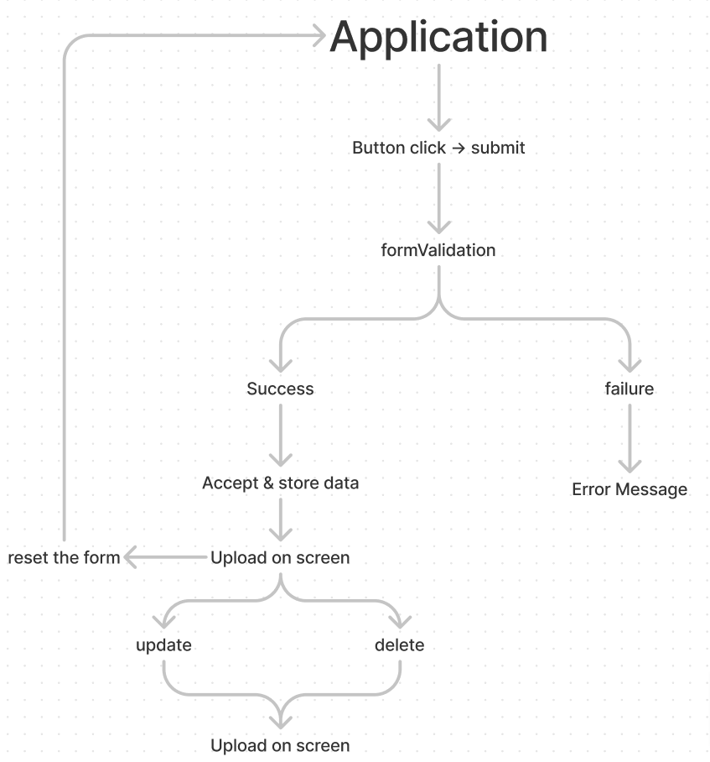
ER Diagram:

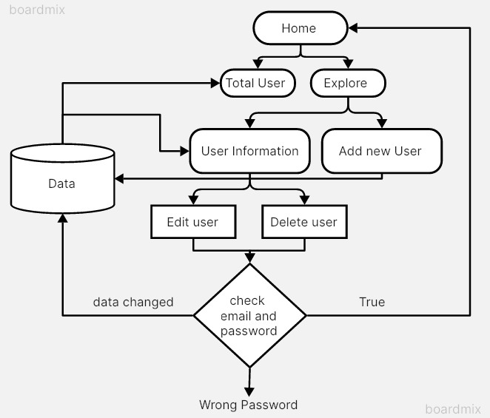

Implementation

Frontend:

- HTML Pages:
- Home Page (`index.html`): Displays user count and navigation to the users' page.
- Users Page (`users.html`): Displays user data in a table and provides editing and deletion options.
- Add New User Page (`add-user.html`): Form to add a new user to the application.

- CSS Stylesheets:
- Stylesheets : Provides styling for the web pages, ensuring a visually appealing user interface.

- JavaScript:
- Client-side scripts (`index.js`): Handles user interactions, form validation, and AJAX requests for dynamic content loading.

Backend:

- Node.js and Express.js:
- Server setup (`app.js`): Configures the Express.js server to handle HTTP requests.
- Routing: Defines routes for different pages and API endpoints.
- Middleware: Implements middleware for parsing request bodies, handling sessions, and authentication.
- Database Connection: Connects to the MySQL database to perform CRUD operations on user data.

- MySQL Database:
- Database Schema: Includes tables for storing user data.
- CRUD Operations: Implements functions for creating, reading, updating, and deleting user records.

- EJS Templates:
- Template files (`*.ejs`): Contains dynamic HTML content with embedded JavaScript for rendering data from the server.

Conclusion
In conclusion, the "User Management App" project presents a comprehensive solution for efficiently managing user data within a web-based environment. Through the integration of modern technologies such as HTML, CSS, JavaScript, Node.js, Express.js, MySQL, and EJS template engine, the application offers a robust platform for user interaction and data handling.
H/w and S/w Requirements

Software Requirements
Operating System | Microsoft Windows
Software
Fronted Software | Vs code (HTML , CSS)
Backend Software | Nodejs, MySql and chrome
Hardware Requirement
Processor | Intel core i5 4th gen
RAM | 2Gb or more
Monitor | Lcd monitor
Keyboard | Normal Keyboard
Mouse | Compatible mouse

Website View
Home Page
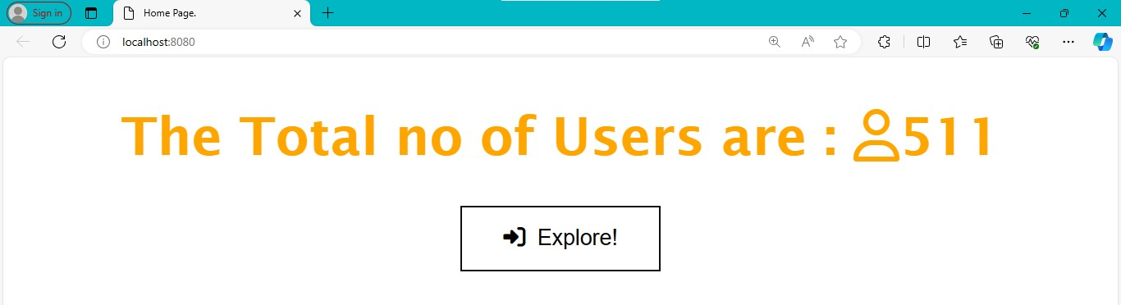

User Page

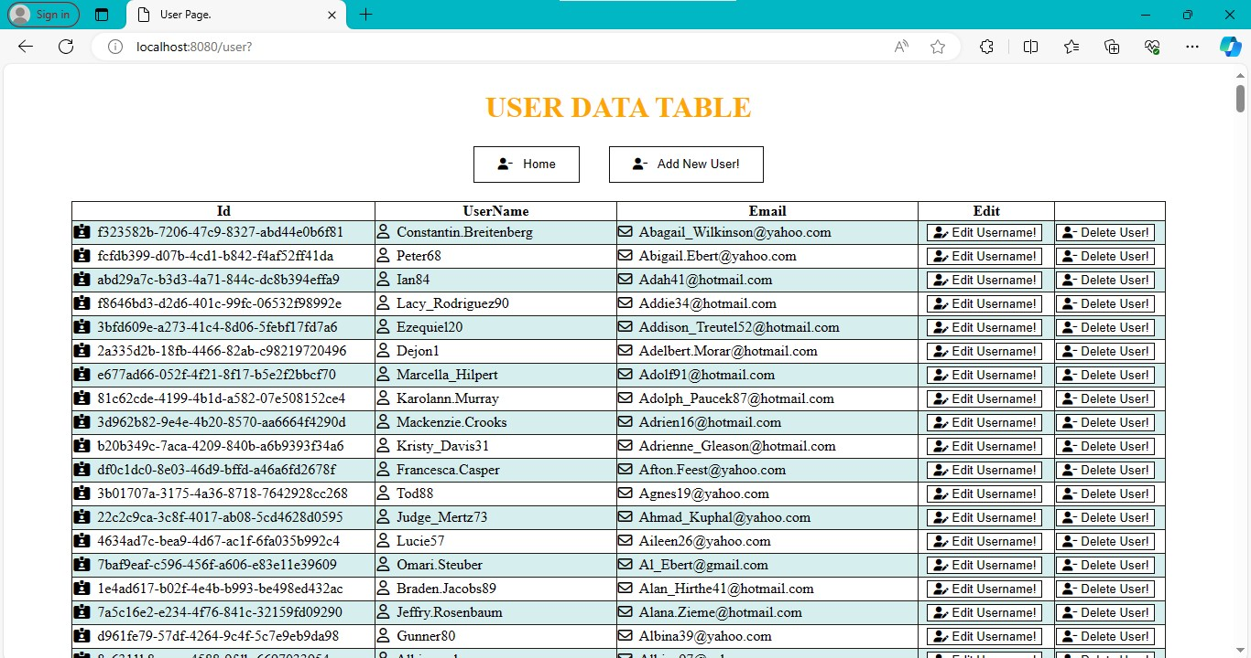

Add New User Page

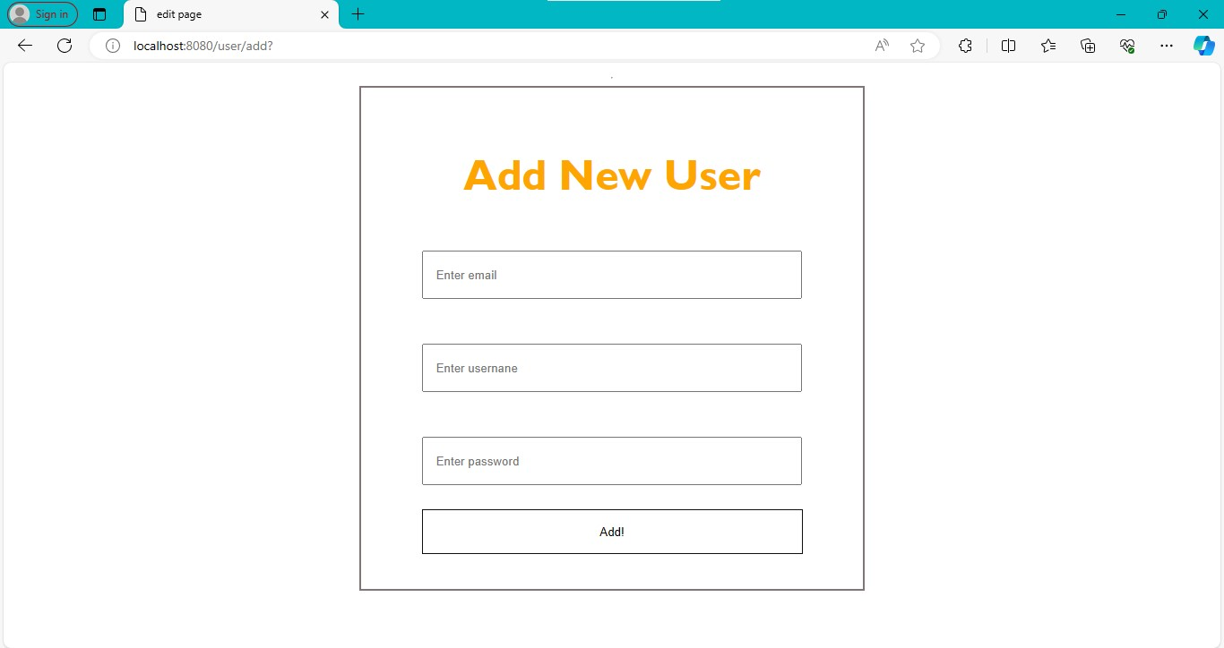
After Filling details :

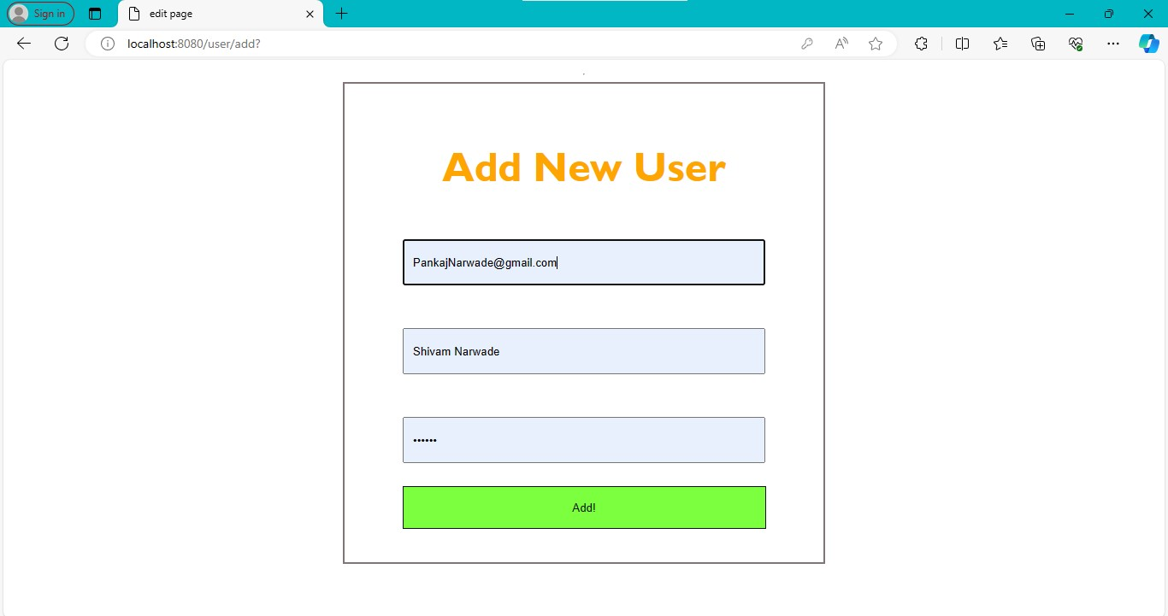

Edit Content Page

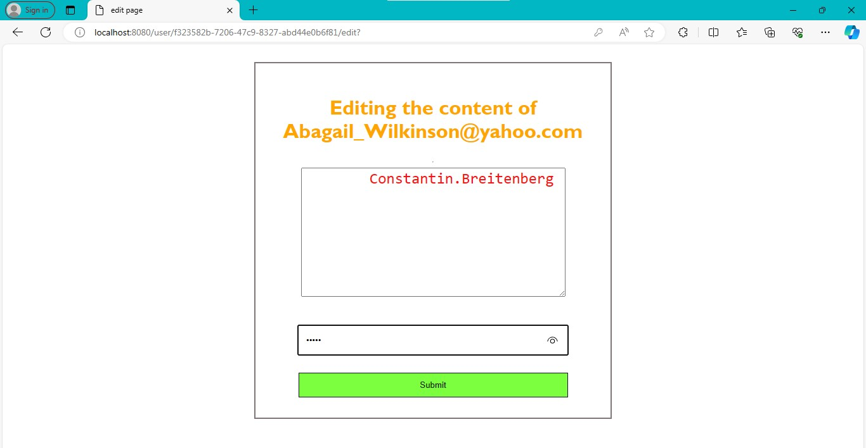
Delete User Page

